|  |
| --- |
| **VLSI Lab** |
|  |
| **LABORATORY REPORT** |
| **Spring 2019** |



|  |  |  |  |  |
| --- | --- | --- | --- | --- |
| **LAB 11** | | | | |
| **Title of Lab Experiment : Implementation of PLA structure using Pseudo NMOS Logic** | | | | |
| **Engr. Rashid Karim** | | | | |
|  | | |  |  |
| __________Kamran__________________ | | | __i140420____ | _A_ |
| STUDENT NAME | | | ROLL NO | SEC |
| Student’s signature and Submission Date: __________17/4/19_________ | | | | |
| ______________________________________ | | | | |
| LAB ENGINEER’S SIGNATURE & DATE | | | | |
|  | | | | |
| **MARKS AWARDED:**  /**10** | | | | |
| ________________________________________________________________ | | | | |
| **NATIONAL UNIVERSITY OF COMPUTER AND EMERGING SCIENCES (NUCES), ISLAMABAD** | | | | |
|  | | | | |
| **LAB:** | **11** | **Implementation of PLA structure using Pseudo NMOS Logic** | | | |

#### **Learning Objectives:**

a. Layout design and verification of Pseudo NMOS based digital designs

#### **Equipment Required:**

Software : L-Edit, T-Spice, W-Edit

1. Lab Summary:

In this lab,we implemented PLA on L-edit using pseudo NMOS and simulated it using W-Edit and T-Spice.

1. Task:

Schematic Screenshot

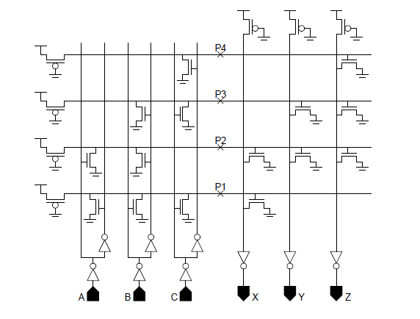

Layout Screenshot

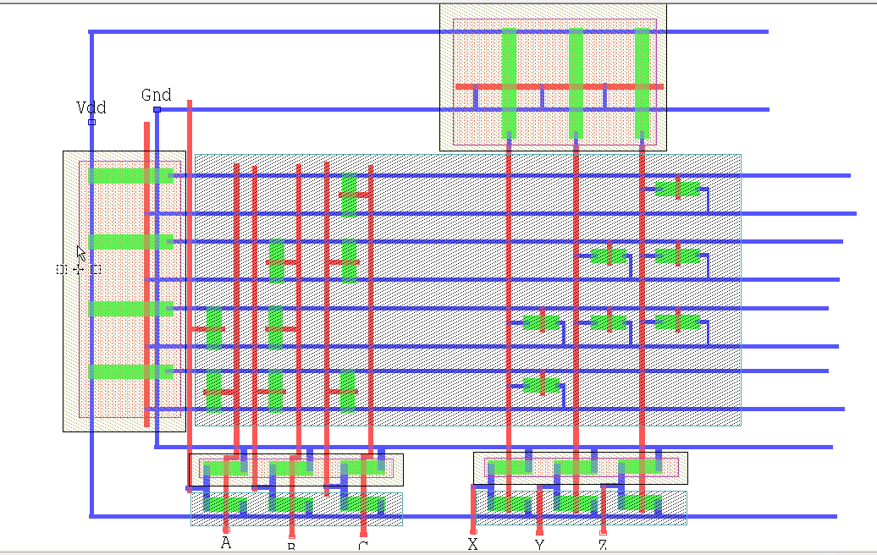

TSpice Code

* Circuit Extracted by Tanner Research's L-Edit Version 13.00 / Extract Version 13.00 ;

* TDB File: C:\Users\i140420\Desktop\Kamran_VLSI_11_17-4\Kamran_vl_11.tdb

* Cell: Cell0 Version 1.33

* Extract Definition File: Generic_025.ext

* Extract Date and Time: 04/19/2019 - 14:15

.INCLUDE SpecialDevices.md

.lib "C:\Users\i140420\Desktop\Kamran_VLSI_11_17-4\Generic_025.lib" TT

.tran 10n 100n

v1 A Gnd PULSE (0 5 0 1n 1n 10n 40n)

v2 B Gnd PULSE (0 5 5n 1n 1n 10n 30n)

v3 C Gnd PULSE (0 5 0 1n 1n 10n 30n)

v4 Vdd Gnd 5

.print tran v(A,Gnd) v(B,Gnd) v(C,Gnd) v(X,Gnd) v(Y,Gnd) v(Z,Gnd)

* NODE NAME ALIASES

* 1 = Z (136.56 , -65.14)

* 2 = Y (122.56 , -65.15)

* 10 = Gnd (38.4 , 27.92)

* 11 = X (108.07 , -64.87)

* 14 = Vdd (24.06 , 25.12)

* 21 = A (53.7 , -64.38)

* 22 = B (68.13 , -65.96)

* 23 = C (83.89 , -65.47)

M1 Gnd 3 Y 5 PMOS L=1u W=3u AD=12.75p PD=14.5u AS=12.96p PS=14.64u $ (130.82 -51.72 131.82 -48.72)

M2 Gnd 4 Z 5 PMOS L=1u W=3u AD=11.49p PD=13.66u AS=14.22p PS=15.48u $ (145.32 -51.54 146.32 -48.54)

M3 3 Gnd Vdd 6 PMOS L=1u W=3u AD=32.37p PD=27.58u AS=36.87p PS=30.58u $ (129.78 32.95 132.78 33.95)

M4 4 Gnd Vdd 6 PMOS L=1u W=3u AD=32.37p PD=27.58u AS=36.96p PS=30.64u $ (144.3 32.95 147.3 33.95)

M5 Gnd 17 12 9 NMOS L=1u W=3u AD=9.48p PD=12.32u AS=10.83p PS=13.22u $ (123.46 -33.82 124.46 -30.82)

M6 Gnd 18 12 9 NMOS L=1u W=3u AD=9.48p PD=12.32u AS=10.83p PS=13.22u $ (123.46 -19.96 124.46 -16.96)

M7 Gnd 18 3 9 NMOS L=1u W=3u AD=9.48p PD=12.32u AS=10.83p PS=13.22u $ (138.22 -19.96 139.22 -16.96)

M8 Gnd 19 3 9 NMOS L=1u W=3u AD=9.48p PD=12.32u AS=10.83p PS=13.22u $ (138.22 -5.26 139.22 -2.26)

M9 Gnd 18 4 9 NMOS L=1u W=3u AD=12.45p PD=14.3u AS=13.17p PS=14.78u $ (153.29 -19.82 154.29 -16.82)

M10 Gnd 19 4 9 NMOS L=1u W=3u AD=12.45p PD=14.3u AS=13.17p PS=14.78u $ (153.29 -5.18 154.29 -2.18)

M11 Vdd 3 Y 9 NMOS L=1u W=3u AD=12.63p PD=14.42u AS=13.08p PS=14.72u $ (130.82 -59.71 131.82 -56.71)

M12 Vdd 4 Z 9 NMOS L=1u W=3u AD=11.37p PD=13.58u AS=14.34p PS=15.56u $ (145.32 -59.53 146.32 -56.53)

M13 Gnd 20 4 9 NMOS L=1u W=3u AD=12.45p PD=14.3u AS=13.17p PS=14.78u $ (153.29 9.4 154.29 12.4)

M14 Gnd 12 X 5 PMOS L=1u W=3u AD=13.74p PD=15.16u AS=11.97p PS=13.98u $ (116.07 -51.72 117.07 -48.72)

M15 12 Gnd Vdd 6 PMOS L=1u W=3u AD=32.7p PD=27.8u AS=36.99p PS=30.66u $ (115.08 32.95 118.08 33.95)

M16 Gnd C 13 7 PMOS L=1u W=3u AD=12.27p PD=14.18u AS=13.44p PS=14.96u $ (84.13 -51.78 85.13 -48.78)

M17 Gnd B 15 7 PMOS L=1u W=3u AD=12.27p PD=14.18u AS=13.44p PS=14.96u $ (68.36 -51.96 69.36 -48.96)

M18 Gnd A 16 7 PMOS L=1u W=3u AD=12.54p PD=14.36u AS=13.17p PS=14.78u $ (53.85 -51.96 54.85 -48.96)

M19 17 Gnd Vdd 8 PMOS L=1u W=3u AD=15.84p PD=16.56u AS=36.99p PS=30.66u $ (36.47 -30.75 37.47 -27.75)

M20 18 Gnd Vdd 8 PMOS L=1u W=3u AD=15.84p PD=16.56u AS=36.99p PS=30.66u $ (36.47 -16.9 37.47 -13.9)

M21 19 Gnd Vdd 8 PMOS L=1u W=3u AD=15.96p PD=16.64u AS=36.87p PS=30.58u $ (36.47 -2.2 37.47 0.8)

M22 20 Gnd Vdd 8 PMOS L=1u W=3u AD=15.87p PD=16.58u AS=36.96p PS=30.64u $ (36.47 12.32 37.47 15.32)

M23 Vdd 12 X 9 NMOS L=1u W=3u AD=13.35p PD=14.9u AS=12.36p PS=14.24u $ (116.07 -59.75 117.07 -56.75)

M24 Vdd C 13 9 NMOS L=1u W=3u AD=12.15p PD=14.1u AS=13.56p PS=15.04u $ (84.13 -59.77 85.13 -56.77)

M25 Gnd C 20 9 NMOS L=1u W=3u AD=12.93p PD=14.62u AS=12.69p PS=14.46u $ (79.92 9.17 82.92 10.17)

M26 Vdd B 15 9 NMOS L=1u W=3u AD=12.15p PD=14.1u AS=13.56p PS=15.04u $ (68.36 -59.95 69.36 -56.95)

M27 Gnd B 19 9 NMOS L=1u W=3u AD=11.94p PD=13.96u AS=13.77p PS=15.18u $ (64.02 -5.71 67.02 -4.71)

M28 Gnd B 18 9 NMOS L=1u W=3u AD=11.94p PD=13.96u AS=13.77p PS=15.18u $ (63.7 -20.39 66.7 -19.39)

M29 Vdd A 16 9 NMOS L=1u W=3u AD=12.15p PD=14.1u AS=13.56p PS=15.04u $ (53.85 -59.99 54.85 -56.99)

M30 Gnd A 17 9 NMOS L=1u W=3u AD=11.94p PD=13.96u AS=13.77p PS=15.18u $ (50.22 -34.25 53.22 -33.25)

M31 Gnd 13 19 9 NMOS L=1u W=3u AD=12.09p PD=14.06u AS=13.53p PS=15.02u $ (79.92 -5.61 82.92 -4.61)

M32 Gnd 13 17 9 NMOS L=1u W=3u AD=12.09p PD=14.06u AS=13.53p PS=15.02u $ (79.5 -34.18 82.5 -33.18)

M33 Gnd 16 18 9 NMOS L=1u W=3u AD=12.09p PD=14.06u AS=13.53p PS=15.02u $ (50.24 -20.35 53.24 -19.35)

M34 Gnd 15 17 9 NMOS L=1u W=3u AD=12.09p PD=14.06u AS=13.53p PS=15.02u $ (63.69 -34.18 66.69 -33.18)

* Total Nodes: 23

* Total Elements: 34

* Total Number of Shorted Elements not written to the SPICE file: 0

* Output Generation Elapsed Time: 0.001 sec

* Total Extract Elapsed Time: 1.508 sec

.op

.END

Waveform/Results

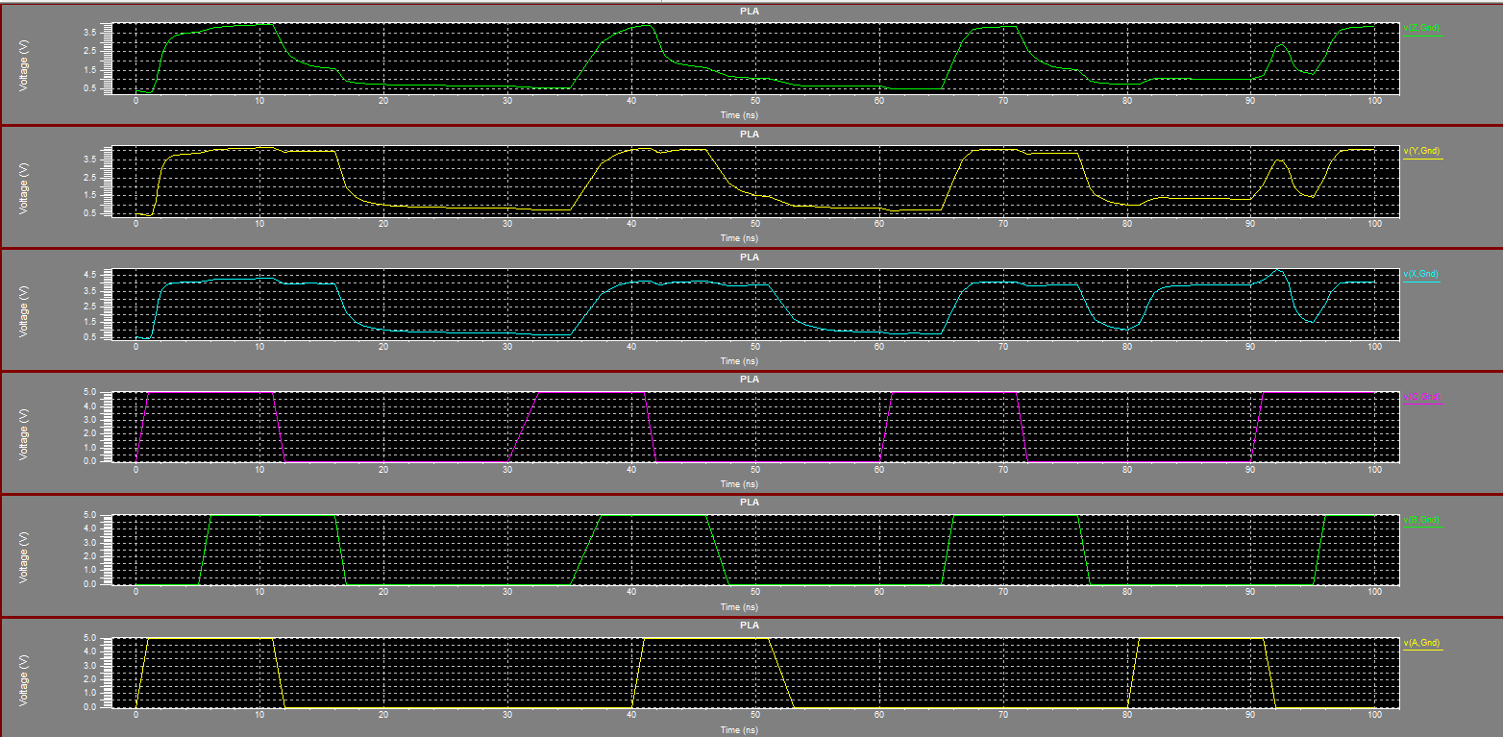

**Submission Declaration by the Student:**

In submitting this lab write-up to the Lab Engineer/Instructor, I hereby declare that:

I have performed all the practical work myself

* I have noted down actual measurements in this writeup from my own working
* I have written un-plagarised answers to various questions
* I have/have not obtained the desired objectives of the lab.

Reasons of not obtaining objectoves (if applicable):

___________________________________________________________________

___________________________________________________________________

___________________________________________________________________

___________________________

Student’s signature and Date

**Student Evaluation by the Lab Engineer:**

The Lab Engineer can separate this page from the writeup and keep it for his/her own record. It must be signed by the student with date on it.

* **Lab Work:** objectives achieved (correctness of measurements, calculations, answers to questions posed, conclusion) ________/30
* **Lab Writeup:** Neatness, appropriateness, intime submission ________/10
* **Troubleshooting:** Were the student able to troubleshoot his/her work when it was purposedly changed? ________/10
* **TOTAL:** ________/50

**Feedback on student behaviour:**

***Encircle*** your choice. -2 means poorest/worst/extremely inadequate/irrevlevant, 0 gives an average score, and +2 means best/most relevant/most adequate.

* Did the student join the lab at the start/remained in lab? -2 -1 0 1 2
* Did the student remain focused on his/her work during lab? -2 -1 0 1 2
* Rate student's behaviour with fellows/staff/Lab Engineer? -2 -1 0 1 2
* Did the student cause any distraction during the Lab? -2 -1 0 1 2
* Was the student found in any sort of plagiarism? -2 -1 0 1 2

Additional comments (if any) by the Lab Engineer:

__________________________________________________________________

___________________________________________________________________

___________________________________________________________________

___________________________________________________________________

___________________________

Lab Engineer’s signature and Date

**Student's feedback: [Separate this page; fill it; drop in the Drop Box.]**

* Providing feedback for every lab session is optional. No feedback means you are satisified
* The Lab Committee will consider only duly filled forms submitted within one week after the lab
* This feedabck is for LAB session: LAB Number: _____, Date: _____________________
* General (to provide feedback on a persistent practice/ocurrence in LABs).
* Your current CGPA is in the range 4.00 to 3.00/2.99 to 2.00/1.99 to 1.00/0.99 to 0.00

**This feedback is:**

* For a Particular
* Who conducted the LAB? __________________________________________________
* Actual Start time: _______________ Total Duration of Lab: _______________________
* Instruction Duration: _________________ Practical Duration: _____________________
* LAB writeup available before LAB? Yes/No with the Photocopier/in LAB/in SLATE
* Had the theory related to lab been covered in theory class? Yes/No

***Encircle*** your choice. -2 means poorest/worst/extremely inadequate/irrevlevant, 0 gives an average score, and +2 means best/most relevant/most adequate.

|  |  |  |  |  |  |  |  |
| --- | --- | --- | --- | --- | --- | --- | --- |
| **Instruction Session** | Was duration of instruction session adequate? | |  |  |  |  |  | | --- | --- | --- | --- | --- | | **-2** | **-1** | **0** | **+1** | **+2** | |
| How much did you understand about the practical? | |  |  |  |  |  | | --- | --- | --- | --- | --- | | **-2** | **-1** | **0** | **+1** | **+2** | |
| How much content was irrelevant to the practical? | |  |  |  |  |  | | --- | --- | --- | --- | --- | | **-2** | **-1** | **0** | **+1** | **+2** | |
| Did the instructor allowed Q/A and discussion? | |  |  |  |  |  | | --- | --- | --- | --- | --- | | **-2** | **-1** | **0** | **+1** | **+2** | |
| **Practical** | Did you get sufficient time for practical? | |  |  |  |  |  | | --- | --- | --- | --- | --- | | **-2** | **-1** | **0** | **+1** | **+2** | |
| **Lab**  **Engineer** | Presence in lab at all time? | |  |  |  |  |  | | --- | --- | --- | --- | --- | | **-2** | **-1** | **0** | **+1** | **+2** | |
| Ability to convey? | |  |  |  |  |  | | --- | --- | --- | --- | --- | | **-2** | **-1** | **0** | **+1** | **+2** | |
| Readiness to help during practical? | |  |  |  |  |  | | --- | --- | --- | --- | --- | | **-2** | **-1** | **0** | **+1** | **+2** | |
| Readiness to discuss theoretical aspects? | |  |  |  |  |  | | --- | --- | --- | --- | --- | | **-2** | **-1** | **0** | **+1** | **+2** | |
| Helps in troubleshooting? | |  |  |  |  |  | | --- | --- | --- | --- | --- | | **-2** | **-1** | **0** | **+1** | **+2** | |
| Guides hows & whys of troubleshooting? | |  |  |  |  |  | | --- | --- | --- | --- | --- | | **-2** | **-1** | **0** | **+1** | **+2** | |
| **Staff** | How friendly was the lab staff? | |  |  |  |  |  | | --- | --- | --- | --- | --- | | **-2** | **-1** | **0** | **+1** | **+2** | |
| Presence of staff throughout the lab session? | |  |  |  |  |  | | --- | --- | --- | --- | --- | | **-2** | **-1** | **0** | **+1** | **+2** | |
| Impact of availability of staff on your practical? | |  |  |  |  |  | | --- | --- | --- | --- | --- | | **-2** | **-1** | **0** | **+1** | **+2** | |
| **Equipment** | Performance of Electronic Instruments? | |  |  |  |  |  | | --- | --- | --- | --- | --- | | **-2** | **-1** | **0** | **+1** | **+2** | |
| Performance of Breadboard/experiment kit? | |  |  |  |  |  | | --- | --- | --- | --- | --- | | **-2** | **-1** | **0** | **+1** | **+2** | |
| Performance of circuit components esp. ICs? | |  |  |  |  |  | | --- | --- | --- | --- | --- | | **-2** | **-1** | **0** | **+1** | **+2** | |
| **Overall** | Your overall rating for the whole lab session? | |  |  |  |  |  | | --- | --- | --- | --- | --- | | **-2** | **-1** | **0** | **+1** | **+2** | |

Other comments: _________________________________________________________________

_________________________________________________________________

_________________________________________________________________